**Topics: Descriptive Statistics and Probability**

1. Look at the data given below. Plot the data, find the outliers and find out $μ, σ, σ^{2}$

|  |  |
| --- | --- |
| **Name of company** | **Measure X** |
| Allied Signal | 24.23% |
| Bankers Trust | 25.53% |
| General Mills | 25.41% |
| ITT Industries | 24.14% |
| J.P.Morgan & Co. | 29.62% |
| Lehman Brothers | 28.25% |
| Marriott | 25.81% |
| MCI | 24.39% |
| Merrill Lynch | 40.26% |
| Microsoft | 32.95% |
| Morgan Stanley | 91.36% |
| Sun Microsystems | 25.99% |
| Travelers | 39.42% |
| US Airways | 26.71% |
| Warner-Lambert | 35.00% |

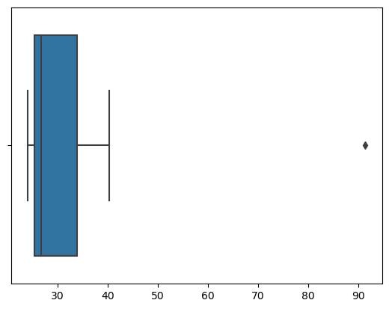

**Outlier : Morgan Stanley - 91.36%**

**Mean $(μ$) : 33.27133333333333**

**Standard Deviation ($σ$) : 16.945400921222028**

**Variance ($σ^{2}$) : 287.1466123809524**



Answer the following three questions based on the box-plot above.

1. What is inter-quartile range of this dataset? (please approximate the numbers) In one line, explain what this value implies.

**IQR = Q3 - Q1 = 12 - 5 = 7**

1. What can we say about the skewness of this dataset?

**Skewness is positive i.e. Right-Skewed.**

1. If it was found that the data point with the value 25 is actually 2.5, how would the new box-plot be affected?

**In that case there would be no Outlier on the given dataset. Because of the outlier the data had positive skewness, it will reduce and the data will be normal distributed.**



Answer the following three questions based on the histogram above.

1. Where would the mode of this dataset lie?

**The mode of this data set lie in between 5 to 10 and approximately between 4 to 8 .**

1. Comment on the skewness of the dataset.

**Right-Skewed i.e. Positive Skewness**

1. Suppose that the above histogram and the box-plot in question 2 are plotted for the same dataset. Explain how these graphs complement each other in providing information about any dataset.

**They both are right-skewed and both have outliers the median can be easily visualized in box plot where as in histogram mode is more visible**.

1. AT&T was running commercials in 1990 aimed at luring back customers who had switched to one of the other long-distance phone service providers. One such commercial shows a businessman trying to reach Phoenix and mistakenly getting Fiji, where a half-naked native on a beach responds incomprehensibly in Polynesian. When asked about this advertisement, AT&T admitted that the portrayed incident did not actually take place but added that this was an enactment of something that “could happen.” Suppose that one in 200 long-distance telephone calls is misdirected. What is the probability that at least one in five attempted telephone calls reaches the wrong number? (Assume independence of attempts.)

**Chances of reaching right number is 199/200**

**Since 5 calls are made so** (199/200)^5

Probability that at least one in five attempted telephone calls reaches the wrong number =

1-(199/200)^5**= 0.025**

1. Returns on a certain business venture, to the nearest $1,000, are known to follow the following probability distribution

|  |  |
| --- | --- |
| x | P(x) |
| -2,000 | 0.1 |
| -1,000 | 0.1 |
| 0 | 0.2 |
| 1000 | 0.2 |
| 2000 | 0.3 |
| 3000 | 0.1 |

X               P(X)     E(X)= X . P(X)     E(X²) = X² . P(X)

-2000       0.1         -200                400000

-1000        0.1         -100                 100000

0                0.2        0                        0

1000         0.2         200                200000

2000        0.3         600                1200000

3000        0.1          300                900000

                              800                 2800000

1. What is the most likely monetary outcome of the business venture?

**Most likely monetary outcome of the business venture is** **$ 2000 as it has maximum Probability  0.3**

1. Is the venture likely to be successful? Explain

**Venture is successful if X is + ve**

**Hence if X is 1000 , 2000 or 3000**

**Probability is  0.2 + 0.3 + 0.1 = 0.6**

**as 0.6 > 0.5 Hence** **venture likely to be successful**

1. What is the long-term average earning of business ventures of this kind? Explain

**long-term average earning of business ventures  = E(X)**

**E(X) = ∑ X.P(X)**

**=(-2000*0.1)+(-1000*0.1)+(0*0.2)+(1000*0.2)+(2000*0.3)+(3000*0.1)**

**=$800**

1. What is the good measure of the risk involved in a venture of this kind? Compute this measure

Risk involved in a venture

Var (X) = E(X²)  - { E(X) }²

=   2800000 -   800²

= **2160000**  ( Quite High)

SD = √Var  ≈ **$ 1470**

As **Variability is Quite high**  hence **Risk is high**